COS30017 Assignment 1 Report
  - Mark Saleh 103994313
This report concerns Assignment 1 of COS30017, which was an application to track climbers' scores in a climbing sport. It was developed in Android Studio using Kotlin. The pertinent Github repository can be viewed at this link:
https://github.com/SoftDevMobDev-2024-Classrooms/assignment01-1MasterSpark

Table of Contents
1UI/UX (User Interface/User Experience) 1
Functionality 4
Process and Demo 5
References 6

UI/UX (User Interface/User Experience)
The UI (User Interface) and UX (User Experience) were guided by the assignment's instructions, as well as by brief research into UX design. It was specified that "Two layouts are needed, one for portrait and one for landscape. A different layout type must be used for each." As such, the LinearLayout type was used for portrait mode and a ConstraintLayout was used for landscape mode. Figures 1 and 2 show how the two layouts would look to an end user.
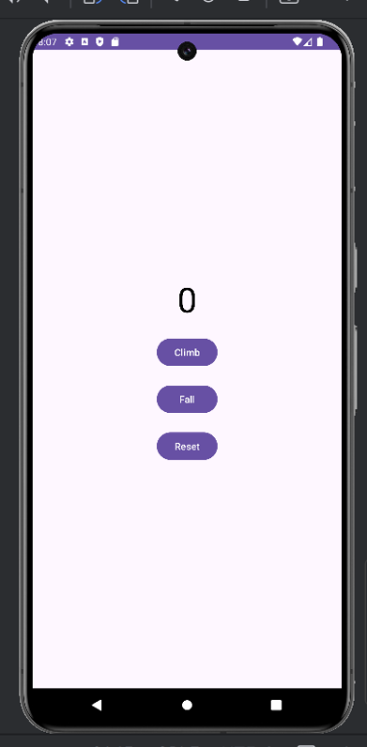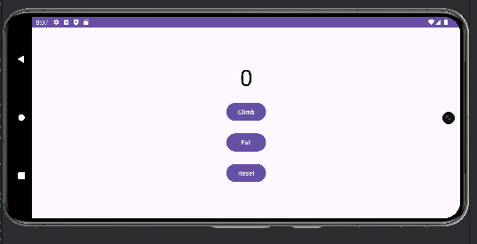
Figure 1 (left): The layout in portrait mode
Figure 2 (right): The layout in landscape mode
This choice of layout type was made in light of LinearLayout being inappropriate for a horizontal screen. Since it is only anchored at the top of the screen, the user would have had to scroll down to see the buttons. ConstraintLayout solves this problem by positioning the buttons relative to each other and to the borders of the screen, thus making the UI more flexible. According to my research, it also costs less memory by solving GPU Overdraw (where one pixel is drawn more than once per frame), and allows more complex UIs to be created,^{[1][2]} although for this simple app, these were not large concerns.
The program also functions in two languages: English and Japanese. This was achieved using two alternative strings.xml files. Figure 1 shows the English UI, while Figure 3 shows the Japanese one.
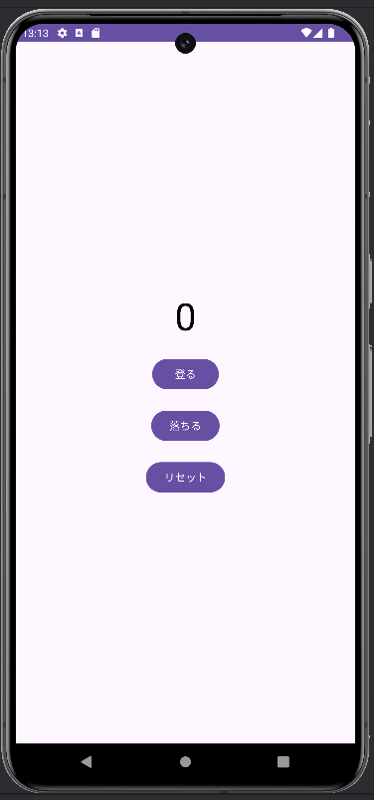
Figure 3: The Japanese UI
The English strings.xml file is as follows:
<resources>
<string name="app_name">Climbing Scorer</string>
<string name="climb">Climb</string>
<string name="fall">Fall</string>
<string name="reset">Reset</string>
</resources>
and the Japanese one is as follows:
<resources>
<string name="app_name">スポーツクライミング点</string>
<string name="climb">登る</string>
<string name="fall">落ちる</string>
<string name="reset">リセット</string>
</resources>

Moreover, the colour of the score changes depending on the zone. This was achieved using the following code in MainActivity.kt:
val color = when (currentHold) {
in 1..3 -> R.color.blue
in 4..6 -> R.color.green
in 7..9 -> R.color.red
else -> R.color.black
}
which calls colour values from the colors.xml file. Note that the colours are based on the currentHold, not the score, so they remain even if the climber falls. Figures 4, 5, and 6 demonstrate the various colours.
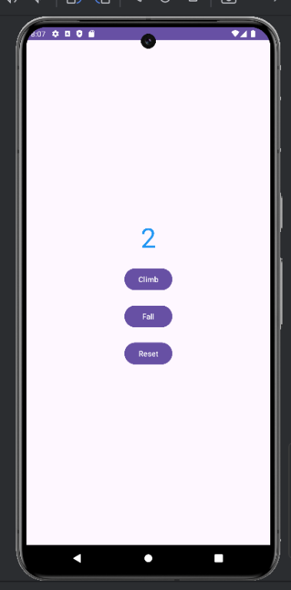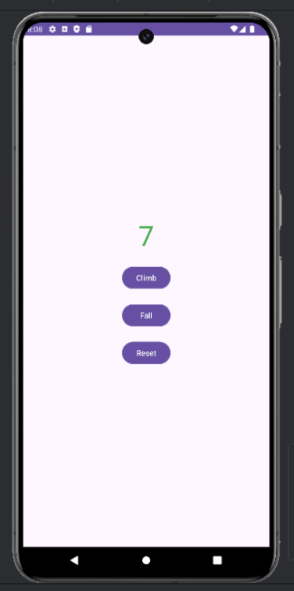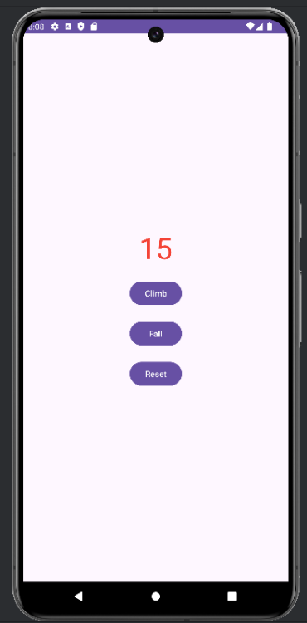
Figures 4, 5, 6: The blue, green and red score colours.
This progression from blue to green to red is based on colour theory, in which these colours are associated with increasing difficulty, as is commonly seen in video games.^{[3]}

Functionality
The code logic uses two variables: currentHold and score, and three functions: climb, fall and reset. Both of them are initialised at 0, and reset to 0 when the reset function is called. currentHold is incremented by 1 when the climb function is called, until it reaches 9, and it is not decreased by the fall function. On the other hand, the climb function increments score by any number from 0 to 3, depending on the currentHold. The fall function decreases the score by 3. Once the ninth hold is reached, neither climb nor fall can have effect unless the reset function is clicked. Below is the code for these three functions:
// Climb function
private fun climb() {
if (currentHold < 9) {
currentHold++
score += when (currentHold) {
in 1..3 -> 1
in 4..6 -> 2
in 7..9 -> 3
else -> 0
}
}
}
// Fall function
private fun fall() {
if (currentHold in 1..8) {
score -= 3
if (score < 0) score = 0
}
}
// Reset function
private fun reset() {
score = 0
currentHold = 0
}

In addition, logs have been added to record every button click, as well as the currentHold and score values at that time. This was accomplished using OnClickListeners. This was done for the sake of debugging, which is further discussed hereinunder. Edge cases, such as the score being out of range, were insured against using statements such as "if (score < 0) score = 0".
Finally, two functions were added to ensure that, even when the screen is rotated, the values do not reset. These are given below:
override fun onSaveInstanceState(outState: Bundle) {
super.onSaveInstanceState(outState)
outState.putInt("score", score)
outState.putInt("currentHold", currentHold)
}
// Ensures the score is maintained if the screen rotates
override fun onRestoreInstanceState(savedInstanceState: Bundle) {
super.onRestoreInstanceState(savedInstanceState)
score = savedInstanceState.getInt("score")
currentHold = savedInstanceState.getInt("currentHold")
val scoreText = findViewById<TextView>(R.id.answer)
updateScore(scoreText)
}

Process and Demo
Proper software development procedures were followed in the making of this code, as can be confirmed by my tutor, Ms Grace Tao, whom I regularly consulted. Unfortunately, I did not realise until I was nearly finished that I was supposed to regularly commit my changes to Github, along with well-written descriptions, and therefore some evidence from the earlier stages of my progress may be lacking. I intend to fill these out here:
As I did not know how to begin an application from scratch, after beginning a new application using the Github classroom link, I copied the code from the Calculations lab and adjusted it to suit this new assignment. Initially, I had problems with the Android Studio emulator due to its computational weight; It would always take at least several minutes to load and to overheat my computer. After attempting several solutions, including borrowing computers from my family and using the university's computers (which failed as students are forbidden from installing apps, including Android Studio, on them), I gave up and simply decided to use mine, despite these unresolved issues. With help from my tutor, the internet, and documentation on the Android Developer website, I soon had a rudimentary application ready to demonstrate despite this setback.
In my demonstration, it was brought to my attention that there were several issues I need to fix. One of them was that the score would reset upon rotating the screen, which was solved using the onSaveInstanceState and onRestoreInstanceState functions. Another was that the colours and zone changed depending on score, not currentHold. This was also subsequently fixed. By this stage, I was also using Github to properly track my changes to the code, which should be verifiable.

References
- Agrawal, K. (2020, July 4). Linear layout V/S Constraint layout. Medium. https://karishma-agr1996.medium.com/linear-layout-v-s-constraint-layout-6b64e7a08ed7
- ConstraintLayout. (n.d.). Android Developers. https://developer.android.com/reference/androidx/constraintlayout/widget/ConstraintLayout
- Tulleken, H. (2015, July 29). Color in games: An in-depth look at one of game design’s most useful tools. Game Developer. https://www.gamedeveloper.com/design/color-in-games-an-in-depth-look-at-one-of-game-design-s-most-useful-tools
Generative AI tools were used as a coding and debugging aid, such as for fixing the error involving rotation, adding logs and adding colours, as well as for feedback on this report after it was completed.

